弘光科技大學
雙聯學位交換計畫分享

學生: 胡凱婷
科系: 應用英語系
雙聯學位交換學校:英國北安大學
研修時間:106年8月- 107年6月

時間: 2019年1月8日製作
目錄
- 行前準備

- 如何準備行李
- 當地商店與銀行
- 花費
- 北安大學就讀心得
- 給弘光的一封信

- 生活照

- 參考資料

行前準備
這是在經歷一連串申請之後得出的經驗, 這邊分享給同學參考。給有在考慮或者是要前往英國就讀的同學們一點行前的心理準備及須知, 讓大家可以不慌不忙並優雅的申請到自己理想的科系及學校!

- 雅思考試 (Ielts Test)
每間學校對於雅思分數的門檻不同, 不過要去英國讀書, 雅思是一定要考的。通常英國大學對國際生的門檻是6-6.5分, 如果考6分以下有些學校接受學生提前去英國念語言加強班。
- 學分抵押
在申請英國學校的過程, 會有科系及課程方面的選擇, 建議同學去查詢英國學校的科系課程, 並向自己的系辦確認將來是否能抵學分。 依個人狀況做決定 (如: 不能抵學分的話是否會影響畢業等。)
- 英國學校申請表
想好自己要申請的科系並填寫好申請表。申請表上資料要詳讀，學校可能會要求個人資料請務必填寫清楚。
- 申請學校初期需準備資料 (依學校求)
1.護照影本
2.英文在學證明
3.英文歷年成績單
4.第三年課程單 (需自備, 如果英國學校要求提前看)
5.雅思成績 (如果成績尚未確定可以在申請後晚一些交)
6. 學校申請表
7. 自傳
8.老師推薦函
9.(如有其他表,依學校要求會檢附表單)
- Conditional offer - 如果英國學校發給你 “條件式入學通知” (Conditional offer), 恭喜你離出國又更進一步了。
- Unconditional offer - 申請學校會在你達到條件後 (如：雅思成績, 學費押金)發給你 “無條件入學通知” 並告知你重要事項。完成後學校會發給你 CAS。
- CAS (Confirmation of Acceptance for Studies) – 拿到CAS確認個人資料無誤後即可申請Tier 4學生簽證。
- Tier 4 學生簽證 (最好預留兩個月的時間辦理)- 申請Tier 4 學生簽證時, 請上https://www.gov.uk/tier-4-general-visa網站填寫線上申請表及詳讀所需資料。雖然一開始會覺得要填的資料很多頁又要很詳細但照著網站一步一步來填寫資料其實不複雜!
- 填寫完申請表、完成線上繳款: 申請費及英國健保費IHS (healthcare surcharge)，選定好面試時間去駐台北英國代表處面試! 務必確定當天需要的資料都有帶齊喔!面試如果資料沒帶齊或銀行存款不合格都會白跑一趟

需檢附的資料 (此為個人經驗,要求文件可能因個人因素更動)
1. 護照
2. CAS
3. 財力證明 (依狀況會有不同要求, 當時我是需要有台幣63萬放在名下戶頭超過一個月)
4. 證明你的法定代理人與你的親屬關係之文件
5. 結核菌素皮膚測試 (Tuberculosis test results, also called TB test)
6.任何面簽需要列印的文件

*重要提醒*
1. 一定要時時刻刻注意信箱，詳讀關於簽證申請的要求及必備文件。學校在發CAS後也會開始寄信聯絡你關於選課及住宿選擇。
2. 課程大綱都可在學校的網站上找到, 如果有問題可以寄信至負責部門詢問。
3.機票及簽證: 去英國時簽證會是30天短期簽證, 讓學生在到英國後一定要10天之內去選定的郵局領BRP (Biometric Residence Permit). 機票雖說建議在簽證下來後再買比較保險不過還是看個人風險承擔。

行李箱裝什麼呢?
- 衣物: 英國秋冬天氣寒冷又時常下毛毛雨, 建議帶保暖褲, 衛生衣, 厚襪子和防風防水的保暖外套及自己愛穿的衣服。英國夏天其實可以穿到短袖，如果有預算的人建議可以帶一個禮拜左右的衣服量，之後可以在當地買。
- 轉接頭、手機充電線、隨身碟、網路線 – 可以在台灣買足夠的轉接頭帶到英國，之後想去歐洲旅遊的話也可以帶歐洲的轉接頭。五金材料行的東西在英國都不便宜，充電線怕一年內故障也很建議多帶一條。
- 筆電 – 建議帶自己的筆電因為課程通常會需要上網做作業，雖然學校圖書館會有電腦, 也會提供筆電租借,不過長久下來也是一筆消費。
- 生活小物 - 英國物價比較貴, 不想花錢在瑣碎物品上的話都可以從台灣帶過去，不過依照經驗，自己帶了衣服跟毛毯差不多就把行李箱塞滿了。
- 保養品/化妝品 – 記得超過100ml的液體要放進托運,如果是手提行李裝小於100ml的要全部放進一個透明夾鏈袋中，英國對於手提行李的檢查相當嚴格。
- 眼鏡及隱形眼鏡 – 英國配新眼鏡或隱形眼鏡花費較大，配好的眼鏡大概都要花兩三百鎊以上, 隱形眼鏡也是一筆不小的花費。建議多帶一些隱形眼鏡。
- 零食 – 帶一些自己喜歡喝的東西、麥片等。帶小零食在初期習慣英國環境及交通時很有幫助。注意乳製品及肉製品是規定不能帶進英國的, 被發現會被罰款。(如果上網查, 很多人還是冒險帶了一堆泡麵), 學姊不建議冒這樣的風險哈哈。
- 很多網友推薦帶大同電鍋，不嫌麻煩的人可以帶。

建議英國買的物品
- 電器用品 – 電子鍋, 電熱水壺, 吹風機, 電捲棒….等
- 廚房用品 – 炒鍋, 鍋鏟, 鍋碗瓢盆杯….等
- 寢室用品 – 檯燈, 床單組,棉被, 枕頭, 浴巾…等
- 盥洗用品 – 洗髮精, 沐浴乳, 乳液…等

連鎖商店:
在英格蘭主要的連鎖超商大概有以下這幾種
(由左至右顏色區隔 最便宜到中貴)
Asda  Lidl  Aldi  Coop | Tesco  Morrison  Sainsbury | M&S  Waitross

英國幾家知名銀行:





申請銀行帳戶:
到當地之後, 去銀行預約辦理銀行卡的時間。
準備文件:
- 向學校申請給銀行的證明文件
- 護照
- BRP
- 住宿證明

出國一年大致花費
學費:
根據學校科系不同學費也不相同, 通常國際生在英國一年學費介於 £10,000-£12,500。
學費資訊在申請學校網站上都可查詢到。
生活費:
學校住宿費一周約 £110-£150。
食物費看個人食量, 學姊食量不多自己煮一個月大概 £80-£100就很足夠。如果住在倫敦市中心, 生活費會再高一些。
交通:
公車卡: 看平常上學交通需求決定。
火車: 建議買一年的Young Person Railcard £30, 買火車票會有折扣通常半價或更多。
建議一開始可以帶一點英國現金及配合使用台灣的visa卡刷卡(確保你的銀行卡可以在國外使用), 添購一些日常生活用品或煮飯用的調味料等。等當地銀行卡辦好即可轉錢到英國。

The reflection of studying in the University of Northampton
My name is Kai-Ting Hu. I’m from Taiwan. I came to the University of Northampton in September 2017. My course is BA International Business Communication (Top up). The course is a year long course and it’s been a busy and fulfilling year for me. I have completed my course in June 2018 and I am currently looking for a job. The experience studying in the University of Northampton was great, I saw a magnificent progress and improvement of myself at the end of the course.
Firstly, I would like to thank all of my teachers in this programme. They have been very supportive in guiding students and delivering knowledge throughout the terms. There were three compulsory courses and the programme allowed students to choose two elective courses from the course list which I think is quite flexible and it also enables students to learn what they are interested in.
Secondly, I think the courses are well designed in terms of the aim and objectives. The term schedules are clear presented, quite easy to follow. It was helpful for me to check on what I have learnt and what I am going to learn. Also, by checking the objectives each week helped me to access and reflect the lessons I learnt in the past weeks. All five modules provided me specific skills in certain areas. For example, Business Communication trained us to write business reports and produce analytical presentations. There were case studies and group discussion in the lessons to help students with analytical writing skills and critical thinking. I realised later that this course has prepared me for my current job searching as I had written a CV and knew my strength and weakness through the course.
Another course was Advanced Business English, where I got to learn with great teachers, who made the course interesting and fun to learn. The course covered a wide range of topics in business field which allow students to gain a deeper insight of business cases, corporation strategies, HR regulations and so on. I especially love the lessons of group debating where we got to rehearse what is going to be like in real life situation while improving our logical thinking and presenting skills.
The programme has taught me a great deal of business knowledge from basic understanding to advanced business level equipped with practical training in the lessons. Every module was closely related and I could apply the theories I learnt from one module to another. Moreover, the reading materials of each module helped me understand the concepts better. With the assistance of the tutors in lectures and seminars, it was not difficult for me to absorb the theories and remember them. I felt a lot confident studying in the University of Northampton and I found it enjoyable doing the assignments. The programme has given me a sense of achievement and yet the challenges I need.
I would say studying in the University of Northampton was indeed a good experience for me. The University provides a good system of personal tutorial and the assistance from the librarian if you are struggling with your assignments. As to social life for international students, the Student Union holds many different societies and welcoming party on campus to make your life more interesting and it is also a good platform to meet new people. I attended several societies during the terms and I did enjoy this free service Student Union provided.
I have gained more confidence in my career skills and living in general thanks to those great people I met. I got all the support from the University of Northampton from education, living, health to mental care. Even though I am far away from my family, I rarely feel lonely because I know there are people who are willing to support me and listen to me when I have problems. Having to leave home to study in England, the unknown parts of my Uni life had been a great risk that I would have never regret taken. It was a great page full of unforgettable adventures added to my life journey.

A letter for HungKuang University
Thanks to HungKuang University and all members of staff who worked on this exchange programme so that I could have this amazing experience in England. The variety of exchange programmes in HungKuang have helped many students go abroad to study and see new things. HungKuang University offers great opportunity and pathways for students who would like to pursue their dream journey and challenge themselves. With the success of the exchange programmes, the opportunity of studying in other countries with lower costs during your time in university has become easier. It is inspiring that students at HKU are encouraged to experience life in different parts of the world, studying a foreign language, and learn new cultures while continue their education both in Taiwan and abroad.
First of all, I am so grateful for the board of Directors who sponsored these programmes and made it possible in the first place. What you have offered was not just the opportunity of going abroad but an open door for students to gain access to higher education, experience acculturation and exploration in life.
Being away from Taiwan and all my family and friends, I have experienced ups and downs whether in academic performance or life in general. And to the struggles I have been through last year about home sick, loneliness, or fears for the unknown, I can now be proud and say to myself that I have done well and I have achieved my goals. Studying in England has been a step stone to start a whole new chapter of my life and certainly broaden my perspectives to the world. I consider myself a very lucky girl because none of these would happen if it weren’t for the supports and efforts from all the educators at university and my family.
Lastly, thank you again for the generous help I received from our brilliant staff in The Office of International and Cross-Strait Affairs, Department of Applied English, Office Of Academic Affairs, to name a few.
As an alumna, I would like to contribute this little journal I made as future reference to students who are going/considering to study in England.

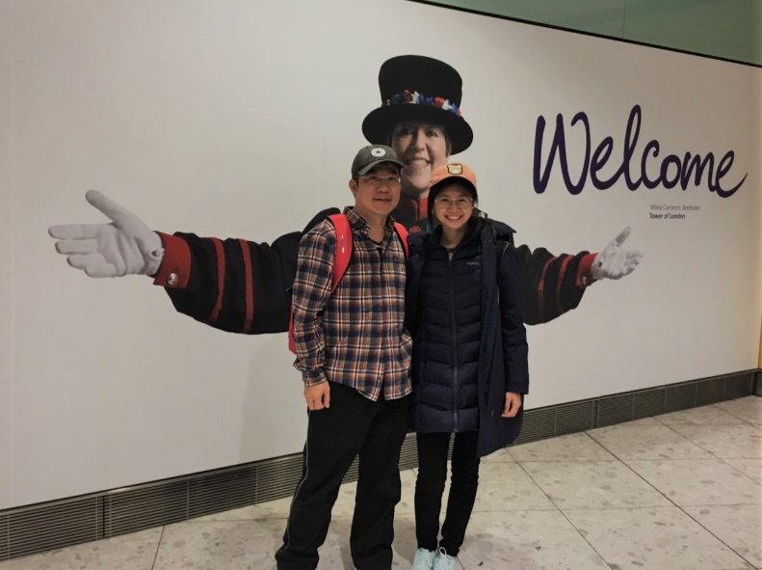
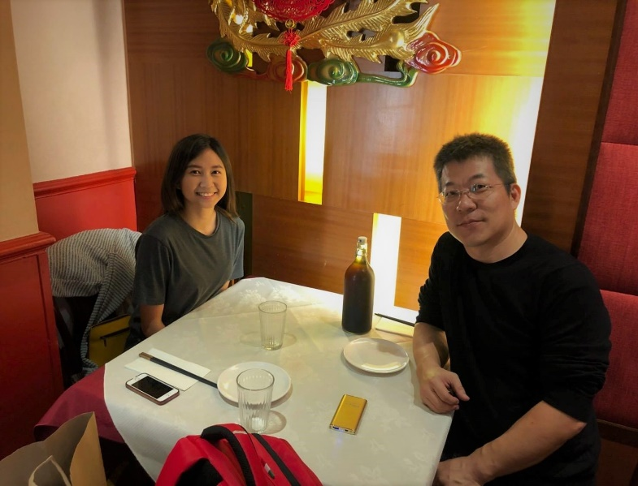
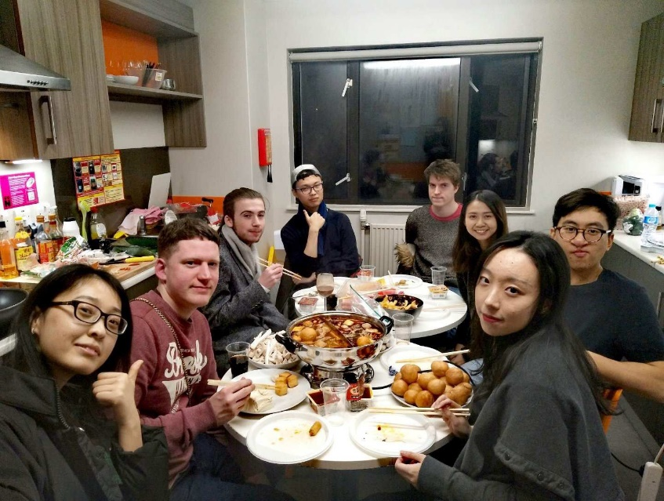
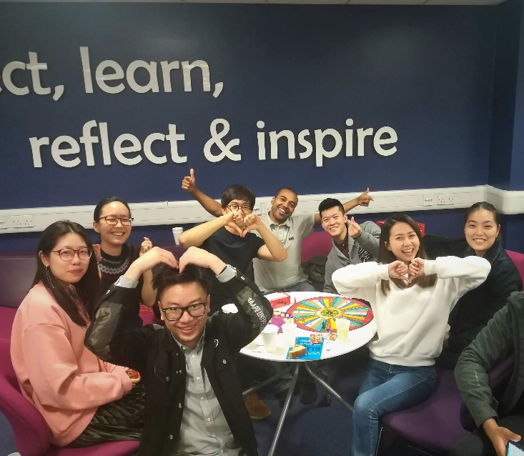



References:
Barclays logo. Retrieved from: https://www.barclayscorporate.com/
Santander logo. Retrieved from: https://www.santander.co.uk/uk/index
Lloyds bank logo. Retrieved from: https://www.lloydsbankinggroup.com/
HSBC logo. Retrieved from: https://www.hsbc.co.uk/

